23AI2003 –Artificial Intelligence for Web Development Lab
URK23CS5003

Ex. No: 3 | Responsive Website Design using Bootstrap

Aim

To design and develop a responsive website using Bootstrap that adapts seamlessly to different

screen sizes and devices by utilizing Bootstrap’s grid system, components, and responsive

utilities.

Description

The responsive website is developed using the Bootstrap framework to ensure consistency in layout and design across various devices such as desktops, tablets, and mobile phones.Bootstrap’s grid system, predefined CSS classes, and UI components are used to create a flexible and responsive layout without writing extensive custom CSS.This experiment demonstrates the effective use of Bootstrap to build modern, mobile-first, and responsive web pages.

Code
<!DOCTYPE html>
<html lang="en">
<head>
<meta charset="UTF-8">
<title>Music Concert - Bootstrap Responsive Website</title>
<meta name="viewport" content="width=device-width, initial-scale=1">
<link href="https://cdn.jsdelivr.net/npm/bootstrap@5.3.2/dist/css/bootstrap.min.css" rel="stylesheet">
<style>
html {
scroll-behavior: smooth;
}

</style>
</head>

<body>
<nav class="navbar navbar-expand-lg navbar-dark bg-dark fixed-top">
<div class="container">
<a class="navbar-brand" href="#">Music Concert</a>
<button class="navbar-toggler" type="button" data-bs-toggle="collapse" data-bs-target="#navbarNav">
<span class="navbar-toggler-icon"></span>
</button>
<div class="collapse navbar-collapse" id="navbarNav">
<ul class="navbar-nav ms-auto">
<li class="nav-item">
<a class="nav-link active" href="#">Home</a>
</li>
<li class="nav-item">
<a class="nav-link" href="#register">Register</a>
</li>
<li class="nav-item">
<a class="nav-link" href="#contact">Contact</a>
</li>
</ul>
</div>
</div>
</nav>
<!-- Spacer for fixed navbar -->
<div style="margin-top: 80px;"></div>
<div class="container mt-5">
<div class="row align-items-center">

<!-- Left Section -->
<div class="col-md-6 mb-4">
<h1 class="mb-3">Live Music Concert 2026 </h1>
<p class="lead">
Join us for an unforgettable night filled with music,
energy, and excitement! Experience live performances
from top artists.
</p>
<!-- Responsive Image -->
<img src="banner.png" class="img-fluid rounded shadow mb-4" alt="Concert Banner">
<!-- Buttons -->
<a href="#register" class="btn btn-primary me-2">Book Tickets</a>
<a href="#" class="btn btn-outline-dark">Learn More</a>
</div>
<!-- Right Section (Register Form) -->
<div class="col-md-6" id="register">
<div class="card shadow p-4">
<h3 class="mb-3 text-center">Register Now</h3>
<form>
<div class="mb-3">
<input type="text" class="form-control" placeholder="Full Name" required>
</div>
<div class="mb-3">
<input type="email" class="form-control" placeholder="Email Address" required>
</div>
<div class="mb-3">
<select class="form-select" required>
<option value="">Select Ticket Type</option>
<option>General</option>
<option>VIP</option>

<option>Backstage</option>
</select>
</div>
<button type="submit" class="btn btn-success w-100">
Register
</button>
</form>
</div>
</div>
</div>
</div>
<div class="container mt-5" id="contact">
<div class="row">
<div class="col text-center">
<h4>Contact Us</h4>
<p>Email: evangeline@gmail.com</p>
<p>Phone: +91 98765 43210</p>
</div>
</div>
</div>
<footer class="bg-dark text-white text-center p-3 mt-4">
© 2026 Music Concert | All Rights Reserved
</footer>
<!-- Bootstrap JS CDN -->
<script src="https://cdn.jsdelivr.net/npm/bootstrap@5.3.2/dist/js/bootstrap.bundle.min.js"></script>
</body>
</html>

Input & Output

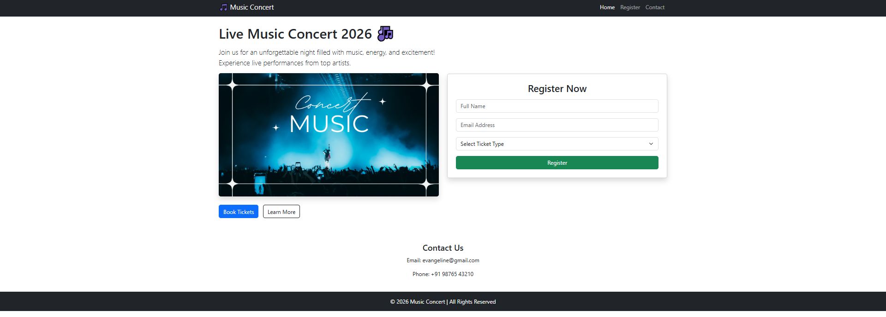

Result
The experiment was successfully completed.

